 **Degree hunt game**

**MINOR PROJECT REPORT**

**UNDER THE SUPERVISION OF:**

**Prof. Mohammad Sarosh Umar**

**Ms. Syeda Shira Moin**

DEPARTMENT OF COMPUTER ENGINEERING

ZAKIR HUSAIN COLLEGE OF ENGINEERING & TECHNOLOGY

ALIGARH MUSLIM UNIVERSITY

ALIGARH (INDIA)-202002

**SUBMITTED BY:**

**Yamini Saraswat Aakrati Jain**

GF-1822 GH-0940

14-PEB-056 14-PEB-065



**ZAKIR HUSAIN COLLEGE OF ENGINEERTNG & TECHNOLOGY**

**ALIGARH MUSLIM UNIVERSITY**

**ALIGARH-202002 (INDIA)**

**CERTIFICATE**

This to certify that the project report entitled **“Degree Hunt Game”** is being submitted by Yamini Saraswat & Aakrati Jain in 5th Semester B.Tech (Computer Engineering) Zakir Husain College of Engineering & Technology, AMU, Aligarh as a part of the curriculum and is a record of their own work carried out under my supervision and guidance. They devoted themselves to complete the work with zeal and enthusiasm.

**Guided & Supervised by:**

**(Prof. Mohammad Sarosh Umar)**

**(Ms. Syeda Shira Moin)**

Department of Computer Engineering

Z.H.C.E.T., AMU.

**Date:** December 27, 2016



**ACKNOWLEDGEMENT**

*We would like to express our gratitude to Prof. Mohammad Sarosh Umar and Ms. Syeda Shira Moin for their guidance and constant support as well as for providing necessary information regarding the project. They have been reverend source of valuable guidance during the period of development of the project. Their technical expertise and suggestions were always fruitful. Their feedback and constructive criticism has been the driving force behind the successful completion of this project. Working under their supervision has been an excellent learning experience. Their guidance has been valuable in a numerous other ways and has eventually motivated us to grow as individuals. We would like to extend our sincere thanks to them.*

*Last but not the least we would like to thank our Parents, Friends and Seniors for their constant support and good wishes*.

**Project Team:**

Yamini Saraswat

Aakrati Jain

**INDEX**

ABSTRACT…………………………………………………………………..05

1. Introduction………………………………………………………………………....06
2. Technology Used:………………………………………………………………….07
   1. Python
   2. Pygame
   3. Tkinter
   4. EasyGUI
3. Implementation………………………………………………………………….....10

3.1 Procedure……………………………………………………………………..17

3.2 Inbuilt functions……………………………………………………………17

3.3 User made functions……………………………………………………...18

3.4 Code Overview………………………………………………………………19

1. Limitations……………………………………………………………………..……..24
2. Conclusion………………………………………………………………………..…...24
3. Future Scope………………………………………………………………………….25
4. References……………………………………………………………………………..25

**ABSTRACT**

The project “Degree Hunt” is designed for the students of our University to inspire and motivate them to take keen interest in knowing about their university and its history. As it is observed that after spending an ample amount of time being in touch with the university, the students though become expertise in their subjects that would lead to their career progression but are unaware or lacking knowledge of the university that provided them with such good quality education! There would be no better platform than a game as “When words are not enough, gestures and images can say more”. This game is a step to eliminate such dearth. The map and the set of questions that the player encounters through the game are totally based on our University.

1) INTRODUCTION

The game is based on the programming language called Python. The game is puzzling and adventurous. The map of the game is designed on the structure of Aligarh Muslim University (AMU). The game assumes that on the day of convocation, the player was so contented and excited that after receiving the degree he dropped it somewhere in the university premises. Now the player is given an opportunity to find his lost degree by answering some knowledgeable and sensible questions. Thus, it is basically like a ‘2D Treasure Hunt’ game.

2) TECHNOLOGY USED

**2.1 Python (version 2.7.12)**

Python is a very powerful and easy to understand language with a very strong library support.

It contains data types that would normally be considered part of the “core” of a language, such as numbers and lists. For these types, the Python language core defines the form of literals and places some constraints on their semantics, but does not fully define the semantics. (On the other hand, the language core does define syntactic properties like the spelling and priorities of operators.)

The library also contains built-in functions and exceptions — objects that can be used by all Python code without the need of an ‘import’ statement. Some of these are defined by the core language, but many are not essential for the core semantics.

The bulk of the library, however, consists of a collection of modules. There are many ways to dissect this collection. Some modules are written in C and built in to the Python interpreter; others are written in Python and imported in source form. Some modules provide interfaces that are highly specific to Python, like printing a stack trace; some provide interfaces that are specific to particular operating systems, such as access to specific hardware; others provide interfaces that are specific to a particular application domain, like the Game development. Some modules are available in all versions and ports of Python; others are only available when the underlying system supports or requires them; yet others are available only when a particular configuration option was chosen at the time when Python was compiled and installed.

**2.2 Pygame (version 1.9.2)**

Pygame is a platform that welcomes all python game, art, music, sound, video and multimedia projects. By definition, it is a cross-platform library designed to make it easy to write multimedia software, such as games, in Python. It requires the Python language and SDL multimedia library. It can also make use of several other popular libraries.

**2.3 Tkinter (version 8.5)**

Tkinter is Python's de-facto standard GUI (Graphical User Interface) package. It is a thin object-oriented layer on top of [Tcl/Tk](http://www.tcl.tk/). It is not the only [GUI Programming](https://wiki.python.org/moin/GuiProgramming) toolkit for Python. It is however the most commonly used one.

**2.4 EasyGUI (version 0.96)**

EasyGUI is a module for very simple, very easy GUI programming in Python. EasyGUI is different from other GUI generators in that EasyGUI is NOT event-driven. Instead, it provides an easy-to-use interface for simple GUI interaction with a user where all GUI interactions are invoked by simple function calls. It does not require the programmer to know anything about tkinter, frames, widgets, callbacks or lambda. It runs on Python 2 and 3, and does not have any dependencies.

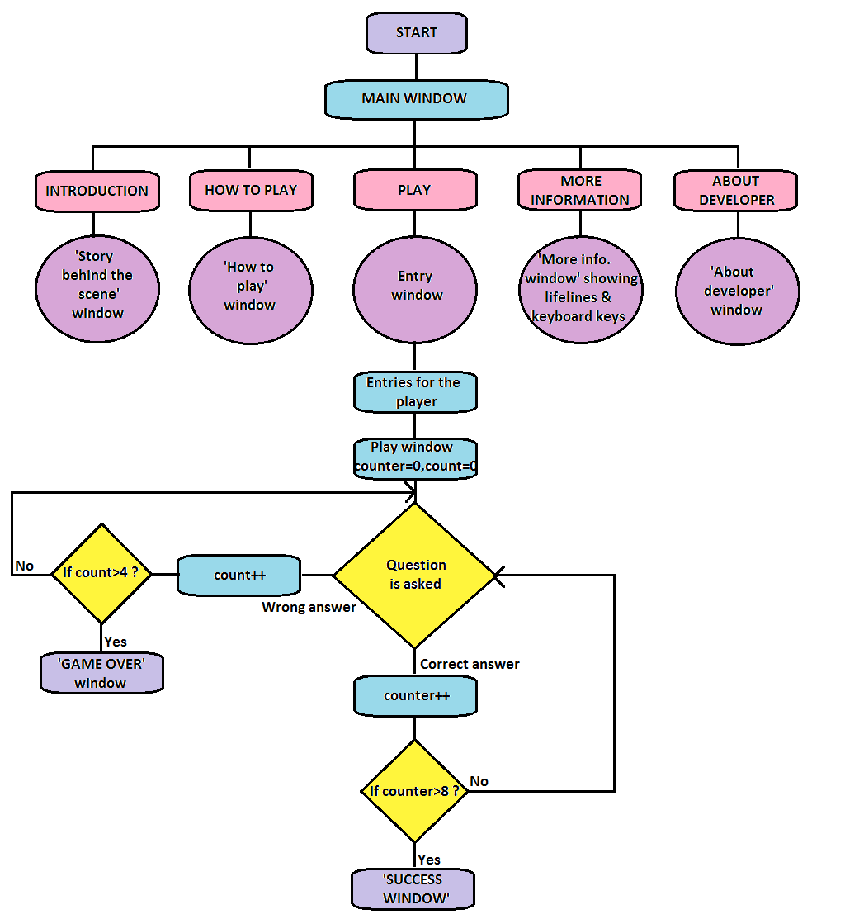

**WORKING OF GAME**

3) IMPLEMENTATION

The project has been implemented in four parts:

1. Question File
2. Information File
3. Game
4. Message box

The QUESTION file is developed in .csv format. It stores the questions and the corresponding x and y coordinates of the answer.

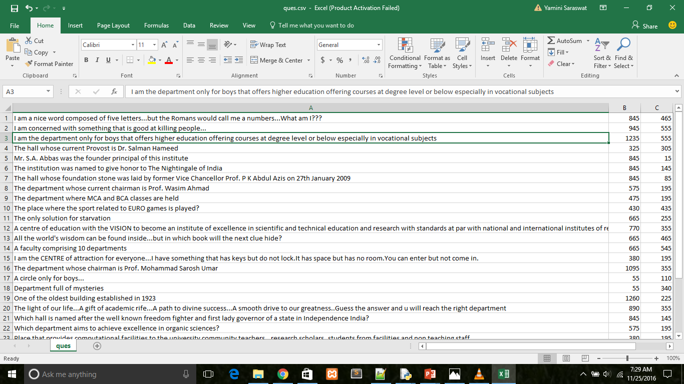

The INFORMATION file is developed in .txt format. It stores the name and degree of the Player.

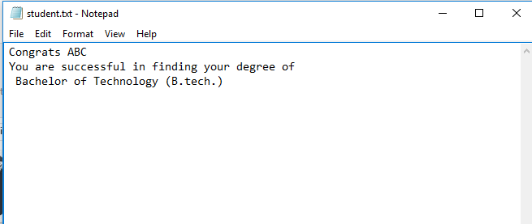

The GAME is implemented using python. It is subdivided into six main windows-Introduction, How to Play, More Information, About Developer, Entry and Play. Introduction, How to Play, More Information, About Developer are implemented using Tkinter and the Play screen is implemented using pygame. The play screen has three more windows i.e. Time Up window, Success window and Game over Window that are implemented using Tkinter.

Here are the screenshots of every window:

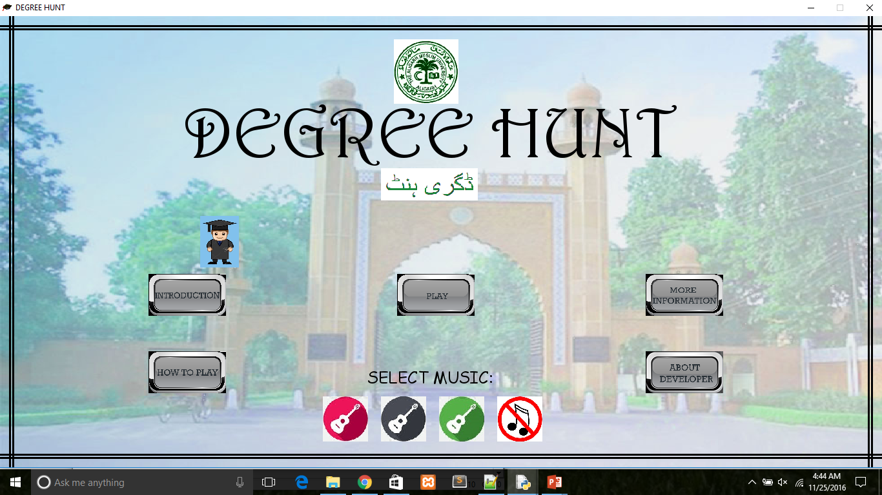

**MAIN WINDOW**

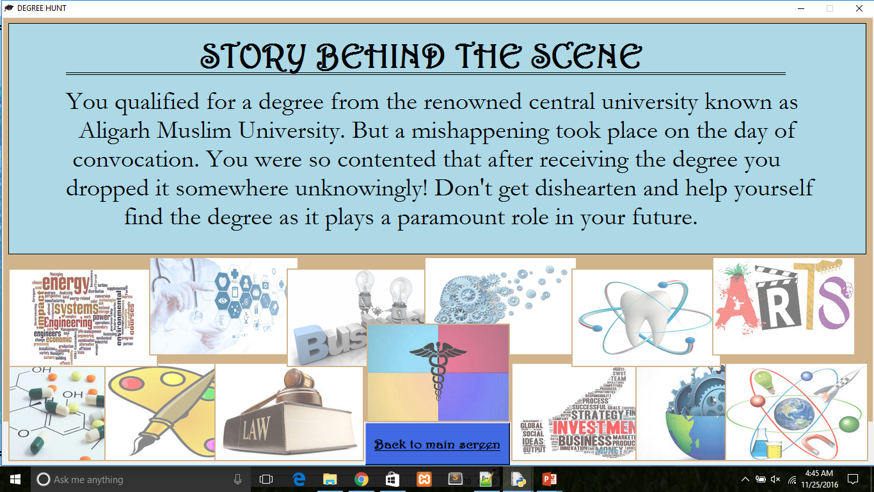

**INTRODUCTION WINDOW**

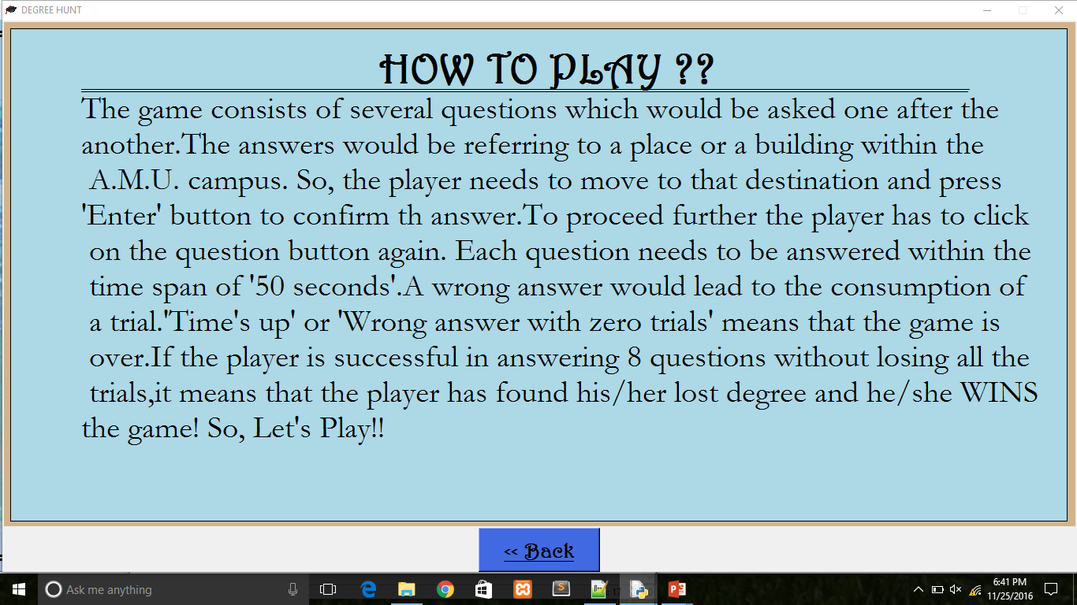

**HOW TO PLAY WINDOW**

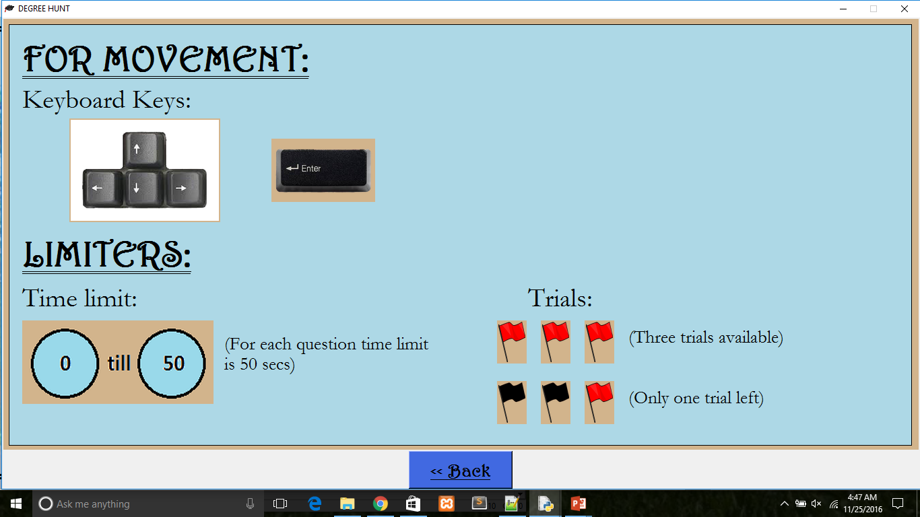

**MORE INFORMATION WINDOW**

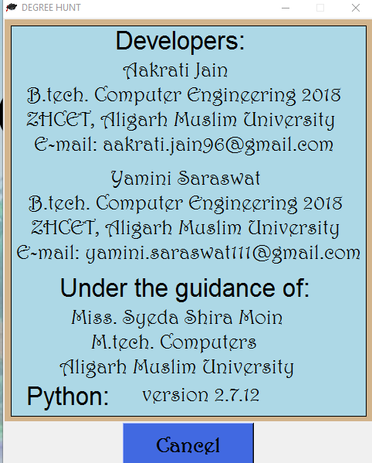

**ABOUT DEVELOPER**

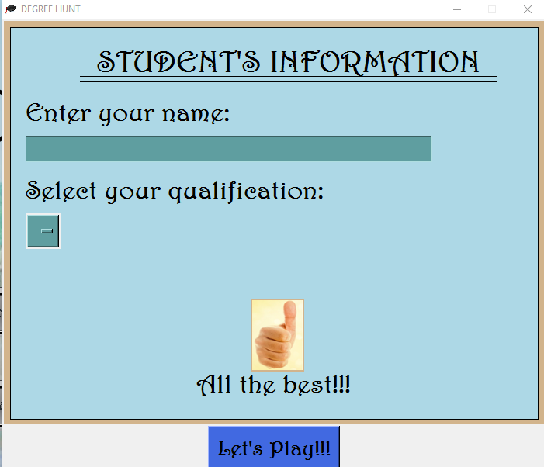

**ENTRY WINDOW**

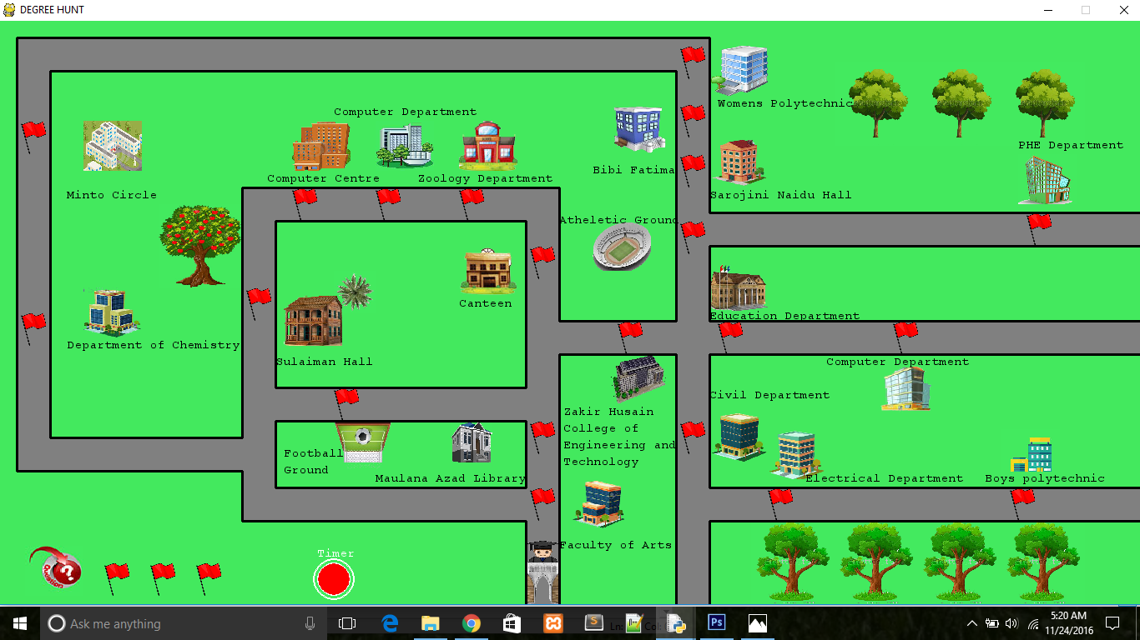

**PLAY WINDOW**

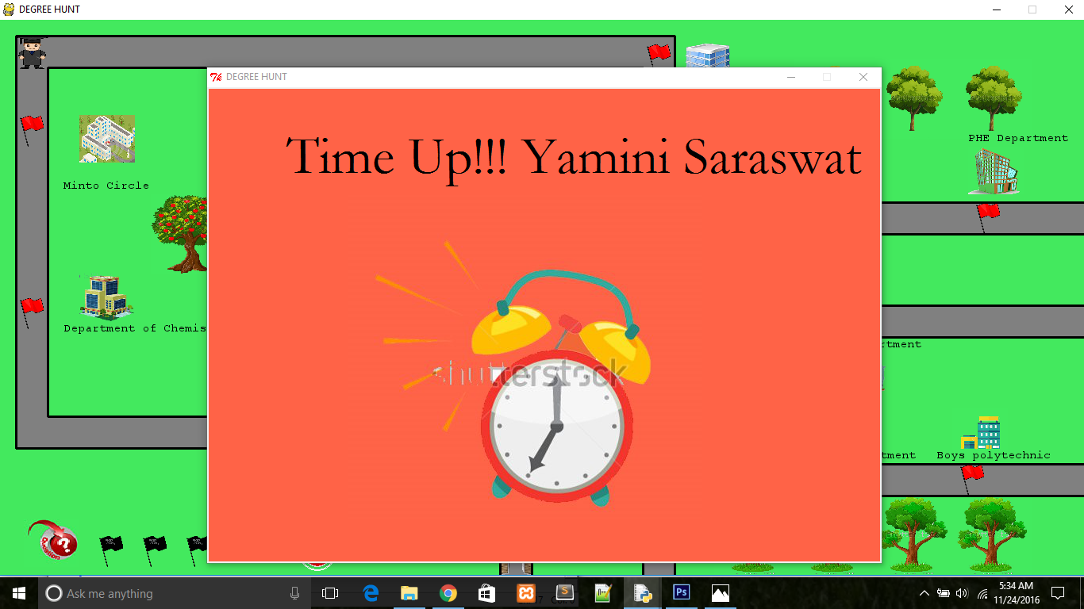

**TIME-UP WINDOW**

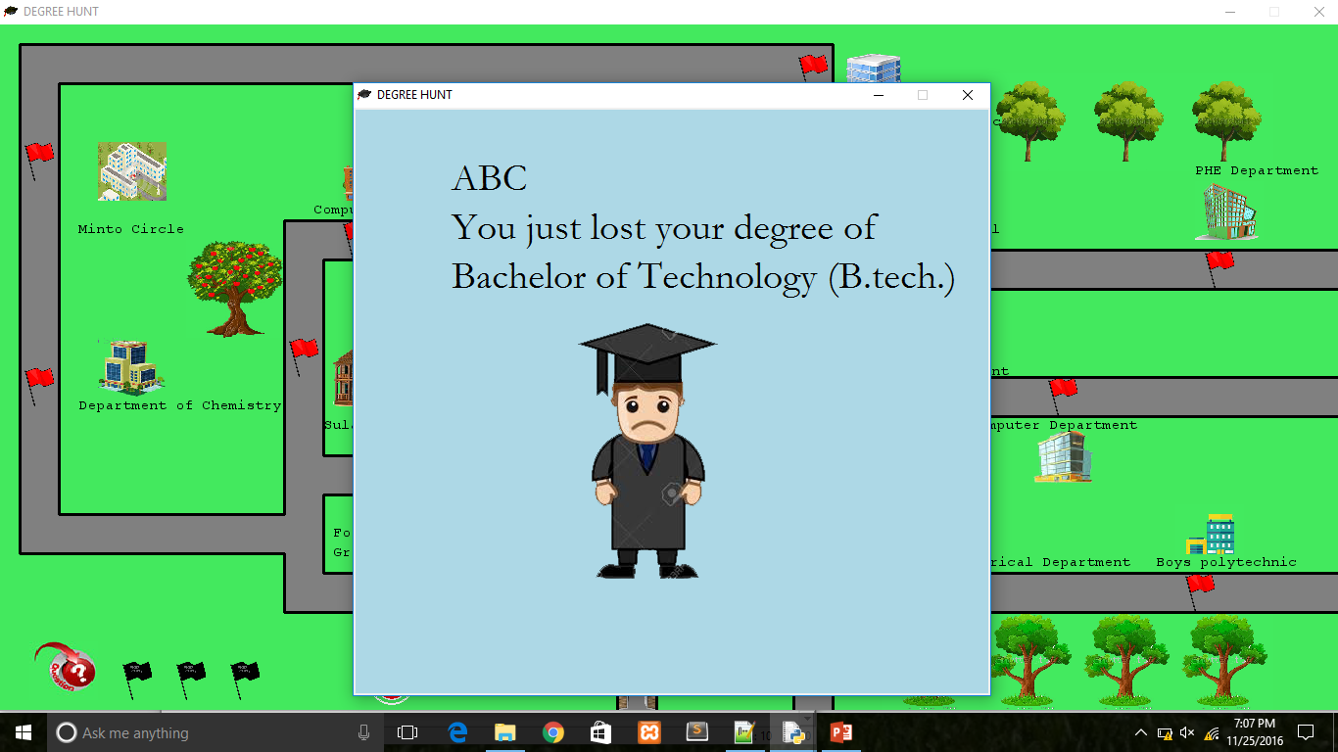

**GAME OVER WINDOW**

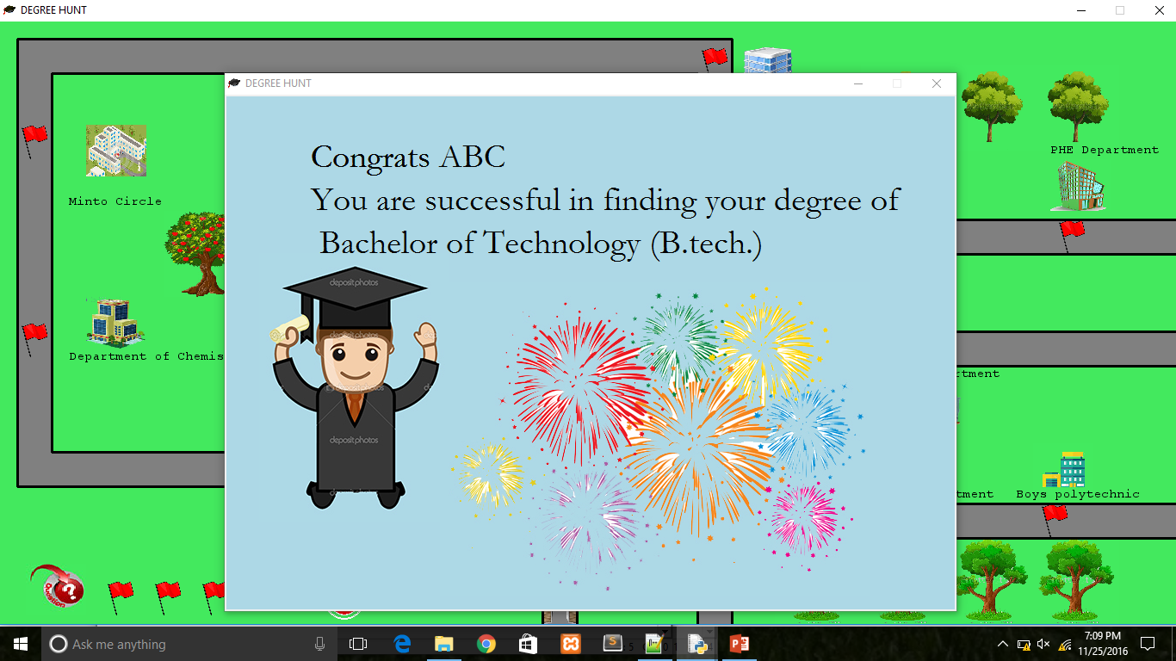

**SUCCESS WINDOW**

MESSAGEBOX is implemented using EasyGUI which is used to implement GUI in python.

**3.1 PROCEDURE**

The code is divided into two parts:

1) MainWindow.py

2) Window3.py

3) TileC.py

MainWindow.py implements the main window, Introduction window, How to Play window, More Information window, About Developer window, Entry window.

Window3.py implements the play window, Time Up window, Success window and Game over window.

TileC.py implements the architecture of the playing window.

**3.2 INBUILT FUNCTIONS**

As python is rich in functions. We make use of many inbuilt functions. Some of them are:

1) pygame.mouse.get_pos ()

2)pygame.display.set_mode ((display width, display height),0,32)

3) pygame.image.load("images/Player.jpg")

4) gameDisplay.blit(screen_text,[x,y])

5) easygui.msgbox('Question:'+strs[rando], title="Question")

6) pygame.mixer.music.load("audio/merachaman_music.Ogg")

7)pygame.mixer.music.play()

8) pygame.display.update()

9) pygame.time.delay(500)

10) root=Tk()

**3.3 USER MADE FUNCTIONS**

Some functions of MainWindow.py:

1) def message_to_screen(msg, color, y_displace=0, size="verysmall"):

2) def text_to_button(msg, color, buttonx, buttony, buttonwidth, buttonheight, size = "verysmall"):

3) def story():

4) def play():

5) def about():

6) def how1():

7) def how2():

Some functions of Window3.py:

8) def main_game(enter_x,enter_y):

9) def question():

Some functions of TileC.py:

10) def process(gameDisplay):

**3.4 CODE OVERVIEW**

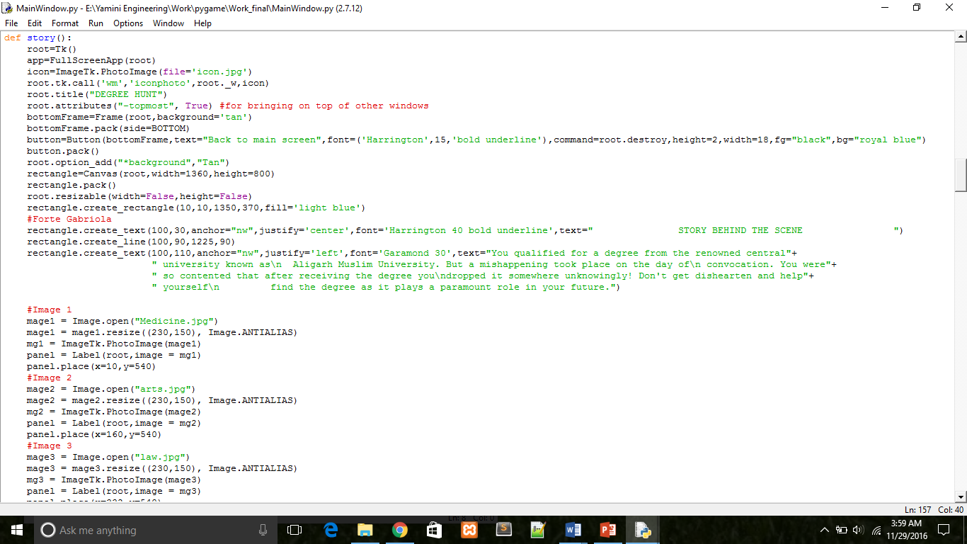

**Story function**

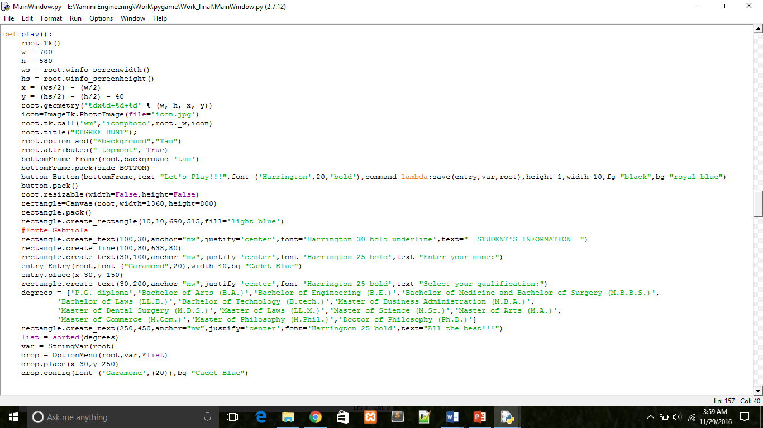

**Play function**

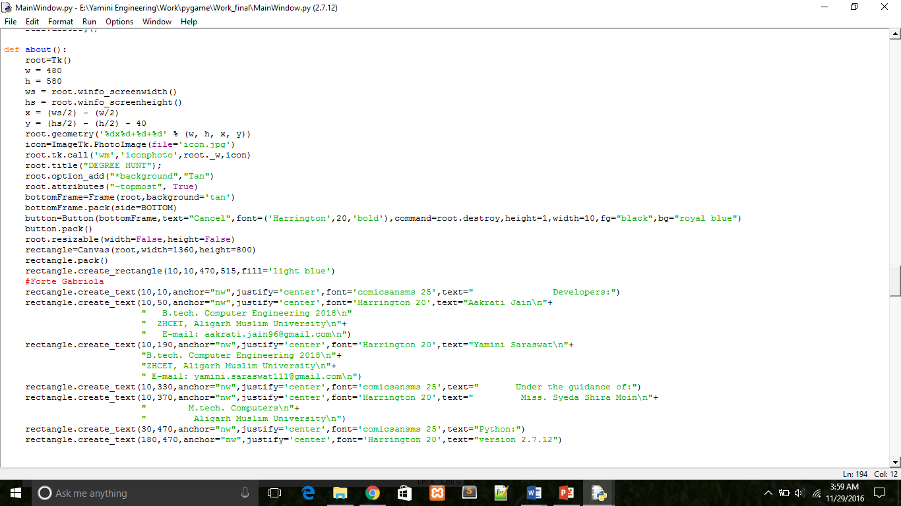

**About function**

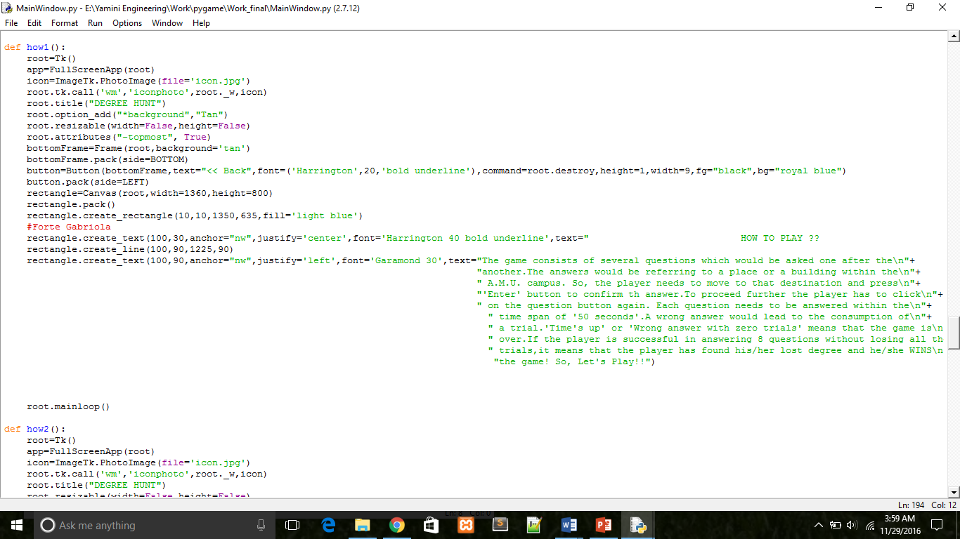

**How1 function**

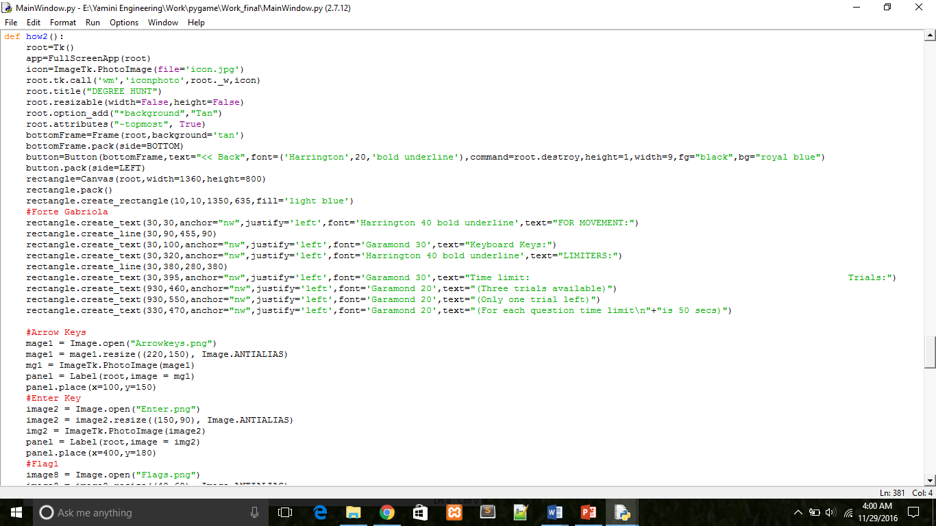

**How2 function**

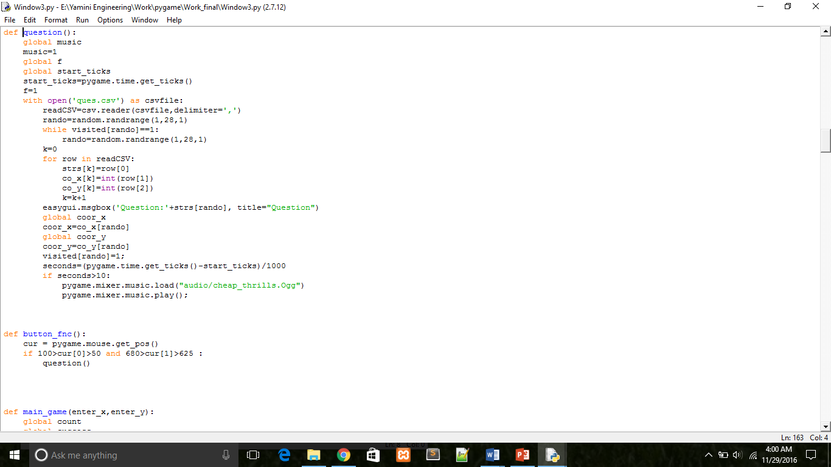

**Question function**

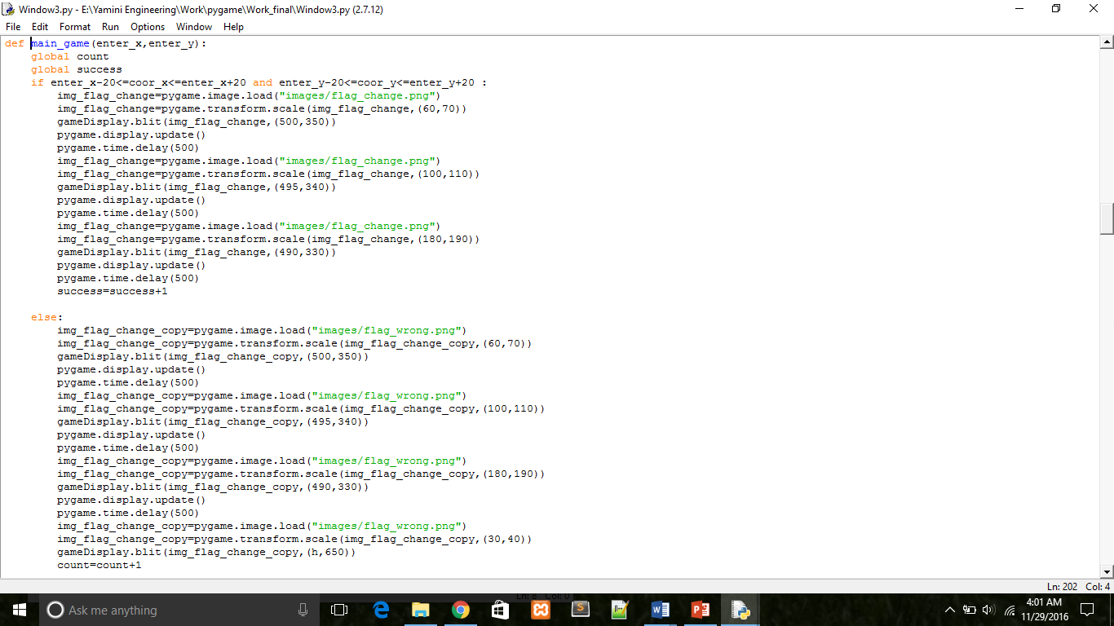

**Main_game function**

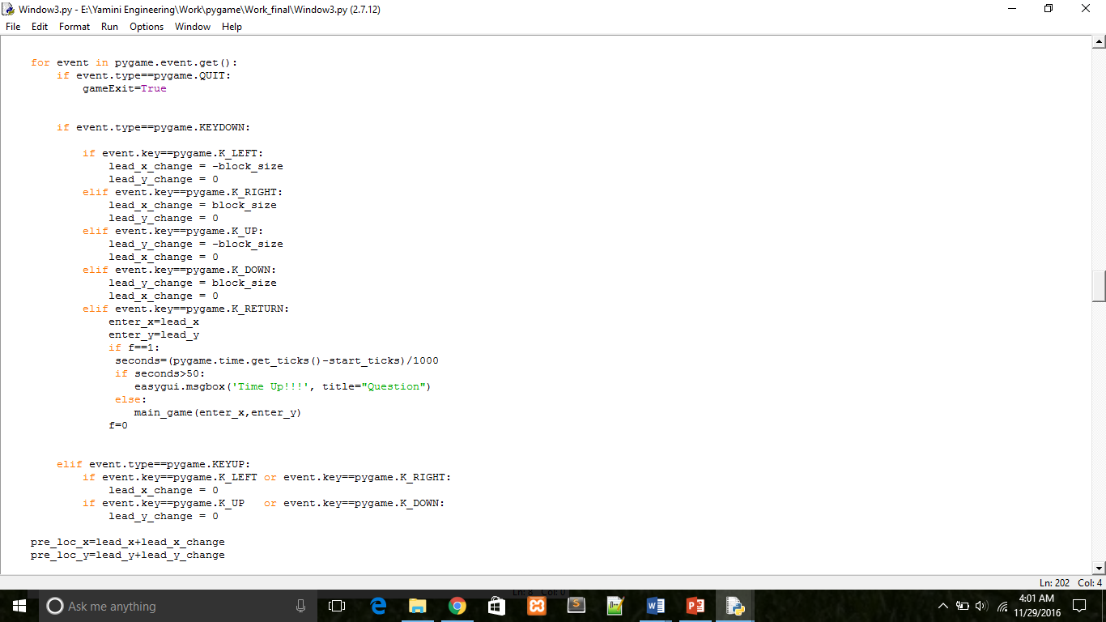

**Code to make left, right, up and down key work**

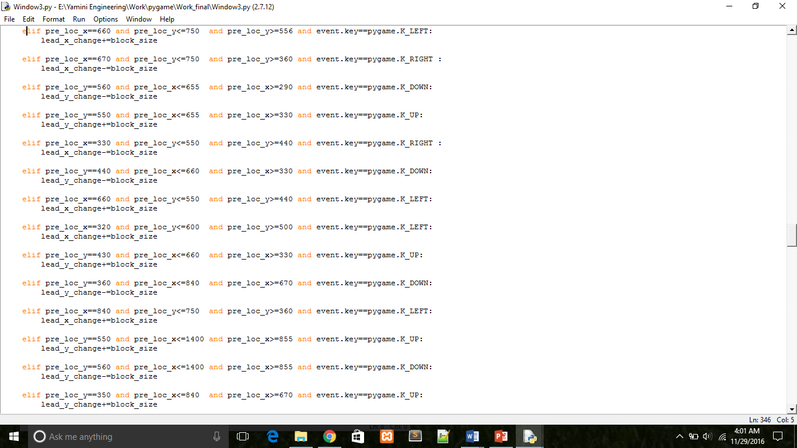

**Code to implement bounds**

4) LIMITATIONS

**Slow:** Slower as compared to other computer games because of multi-layered approach taken in designing Tkinter.

**Basic game:** The game could have been difficult and lengthy by increasing the number of levels so that it may include the entire map of the university.

5) CONCLUSION

The primary objective behind this project was to implement our idea of Degree Hunt. In the initial phase of project we decided to have two levels instead of one in order to make it difficult for the player to achieve his aim of finding the degree. This project helps to endeavor the insights of python. The vast amount of inbuilt function libraries in python helped us to implement our ideas effectively. There were lots of challenges faced with zero experience of python. The initial learning phase was monotonous, but gradually every challenge made it interesting and inspired us to think something that could be new, different and with a better approach.

Though our project is comparatively slow as compared to other computer games that people expect, still we chose it not only for the purpose of developing but also for learning. We came across technological advancements which have certainly changed the way we see the world.

To work in the area of game development was great. It enhanced our time managing and team working skills. We tried to achieve our project as close to our initial idea. We thank our mentor without whom this project would not have been completed. From the beginning till the end she guided us in every step and evaluated our project’s progress weekly.

6) FUTURE SCOPE

With the advancement in technology we will try to incorporate the concept of virtual reality. Virtual reality gaming is where a person can experience being in a three-dimensional environment and interact with that environment during a game. It enables user to explore places. It will make the education more easy and comfortable.

7) REFERENCES

**Reading material:**

PyGame documentation:

**link:** <http://www.pygame.org/docs/>

**PyGame Video Tutorials:**

1. Udemy - Learn Python_ The Complete Python Programming Course (2015)
2. Python (Python Game Development) by ‘thenewBoston’

**link:** https://www.youtube.com/watch?v=K5F- aGDIYaM&list=PL6gx4Cwl9DGAjkwJocj7vlc_mFU-4wXJq

3) PythonGame Development by ‘WilliamFiset’:

**link:** https://www.youtube.com/watch?v=VCf5

hED4BG0&list=PLDV1Zeh2NRsB1l23YFY137LtPcstXKyuQ